B3S Krankenhaus and SGB V Section 75c Compliance for Log360
Tagline: Meet German hospital cybersecurity requirements with continuous monitoring from Log360.

Overview
The B3S Krankenhaus and SGB V Section 75c Compliance extension for Log360 helps German hospitals and healthcare facilities with critical infrastructure designation meet the sector-specific security standard (B3S Krankenhaus) and the statutory cybersecurity obligations under Social Code Book V Section 75c.
Log360 collects and analyzes logs from hospital information systems, clinical applications, cloud environments, and network infrastructure, providing security teams with visibility into patient data access and system integrity events. Compliance teams can monitor control effectiveness and generate BSI-ready audit evidence.

Key Features
- Generate predefined compliance reports aligned to B3S Krankenhaus controls covering access management, clinical system monitoring, and cybersecurity incident detection.
- Track access to electronic health records, detect unusual data exports, and monitor privileged user activity across hospital IT environments in real time.
- Continuously correlate security events across your IT environment to detect suspicious activity and policy violations aligned with B3S Krankenhaus incident detection and response obligations.
- Export audit evidence in PDF and CSV formats for BSI KRITIS audits, hospital management reviews, and internal healthcare cybersecurity governance.
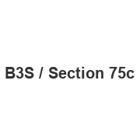
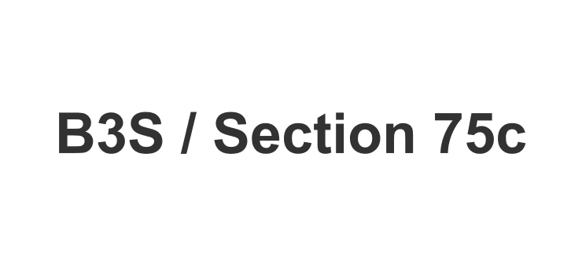

Screenshots
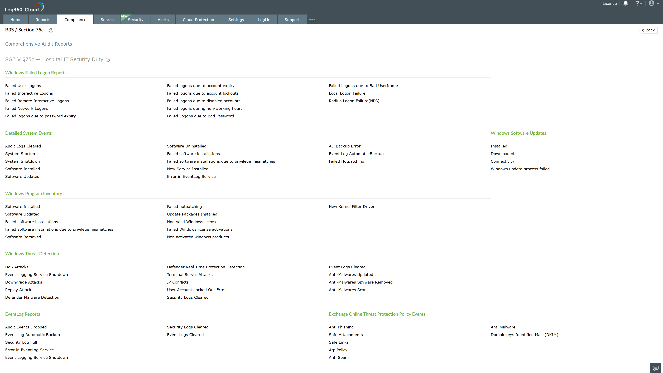
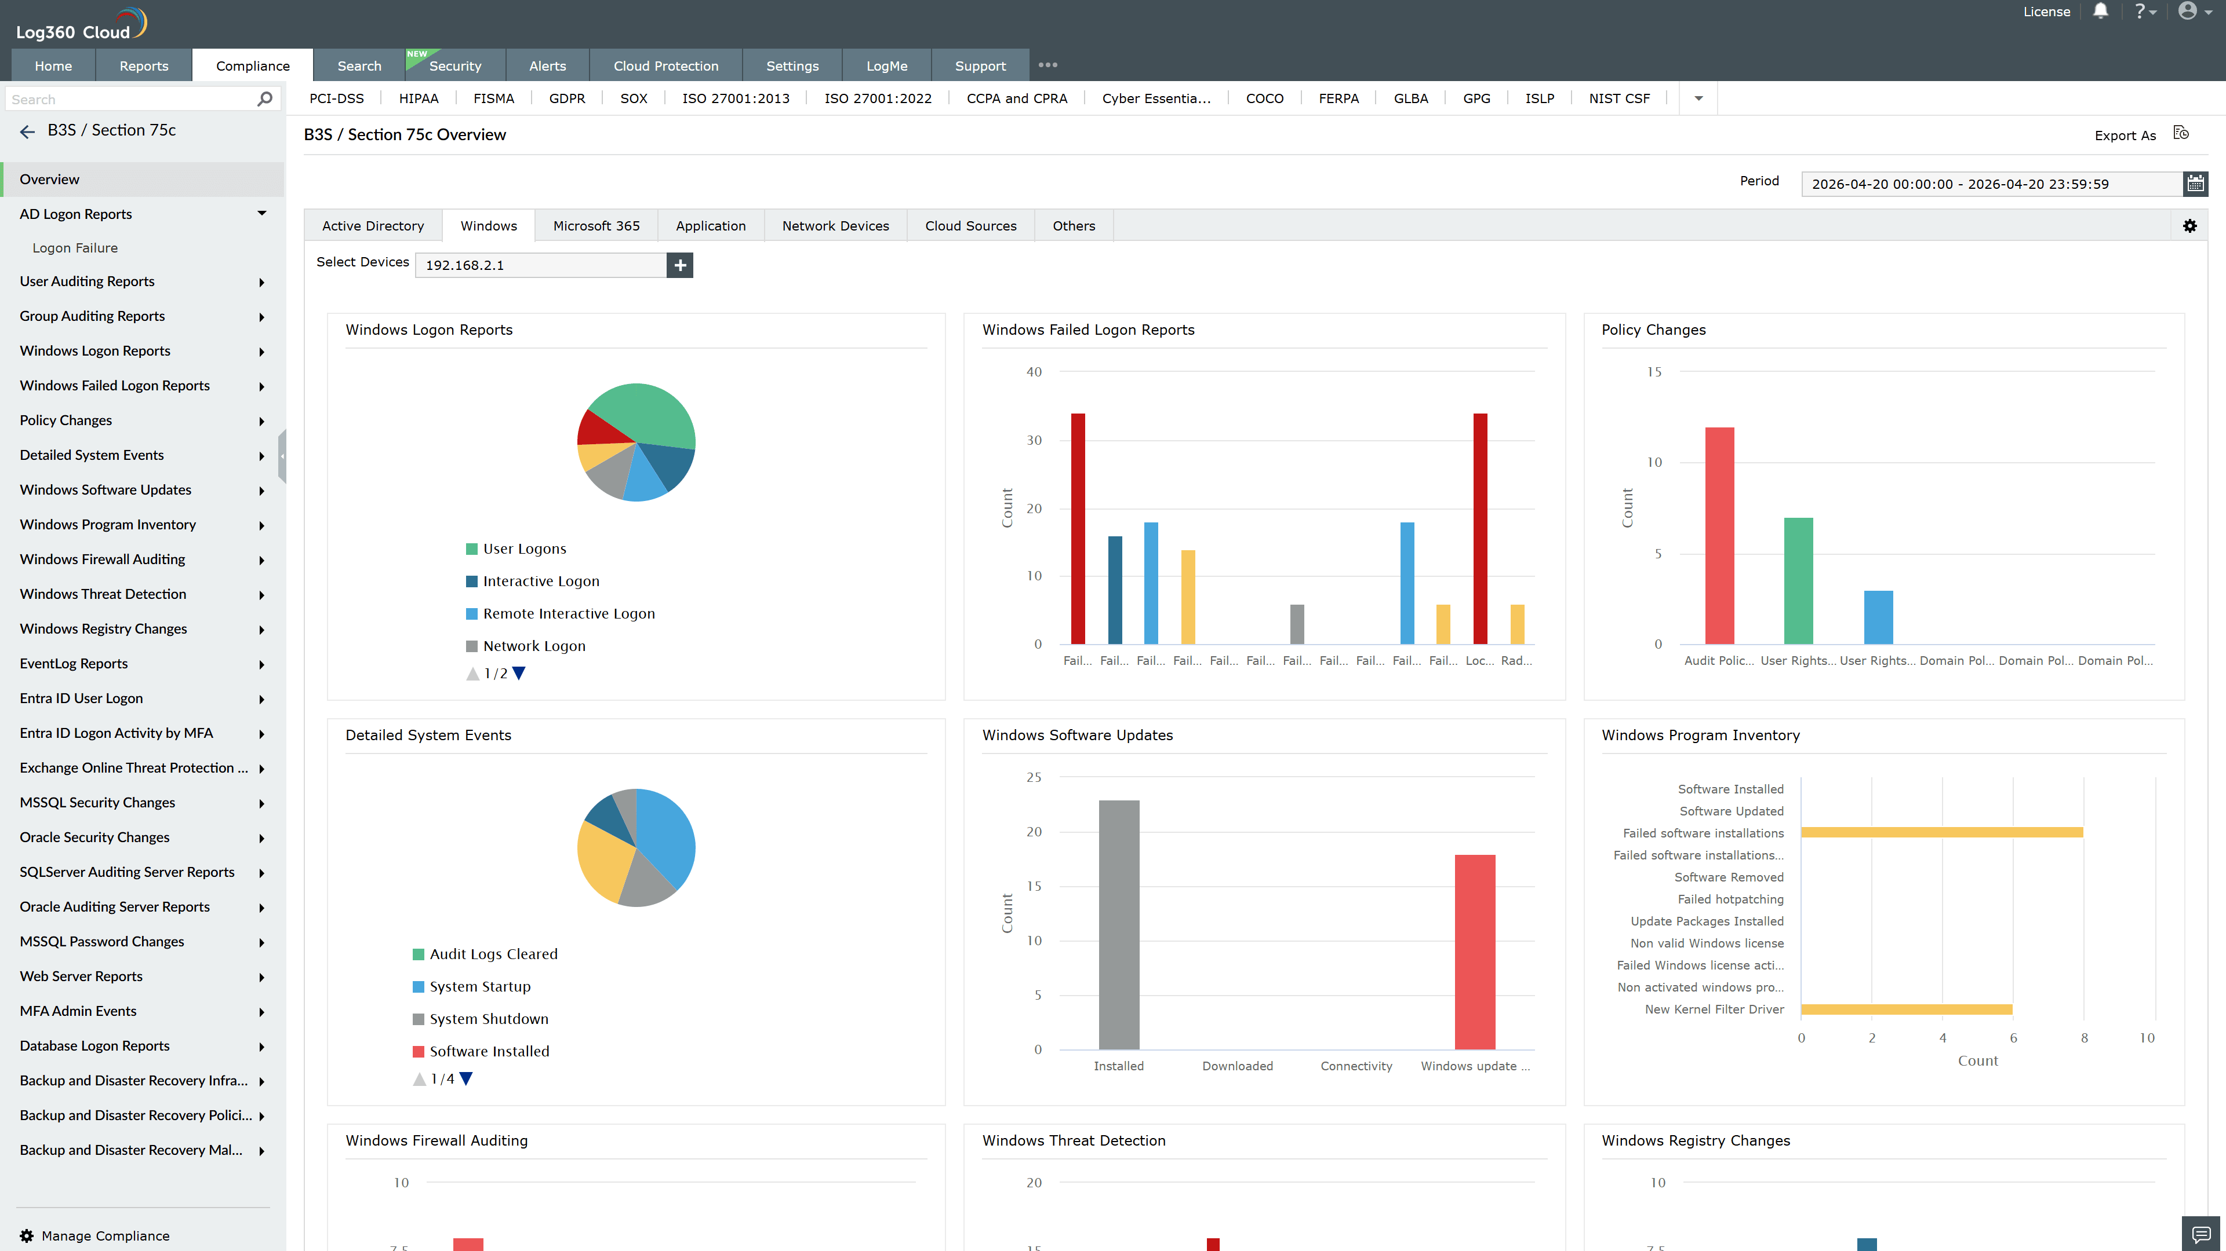
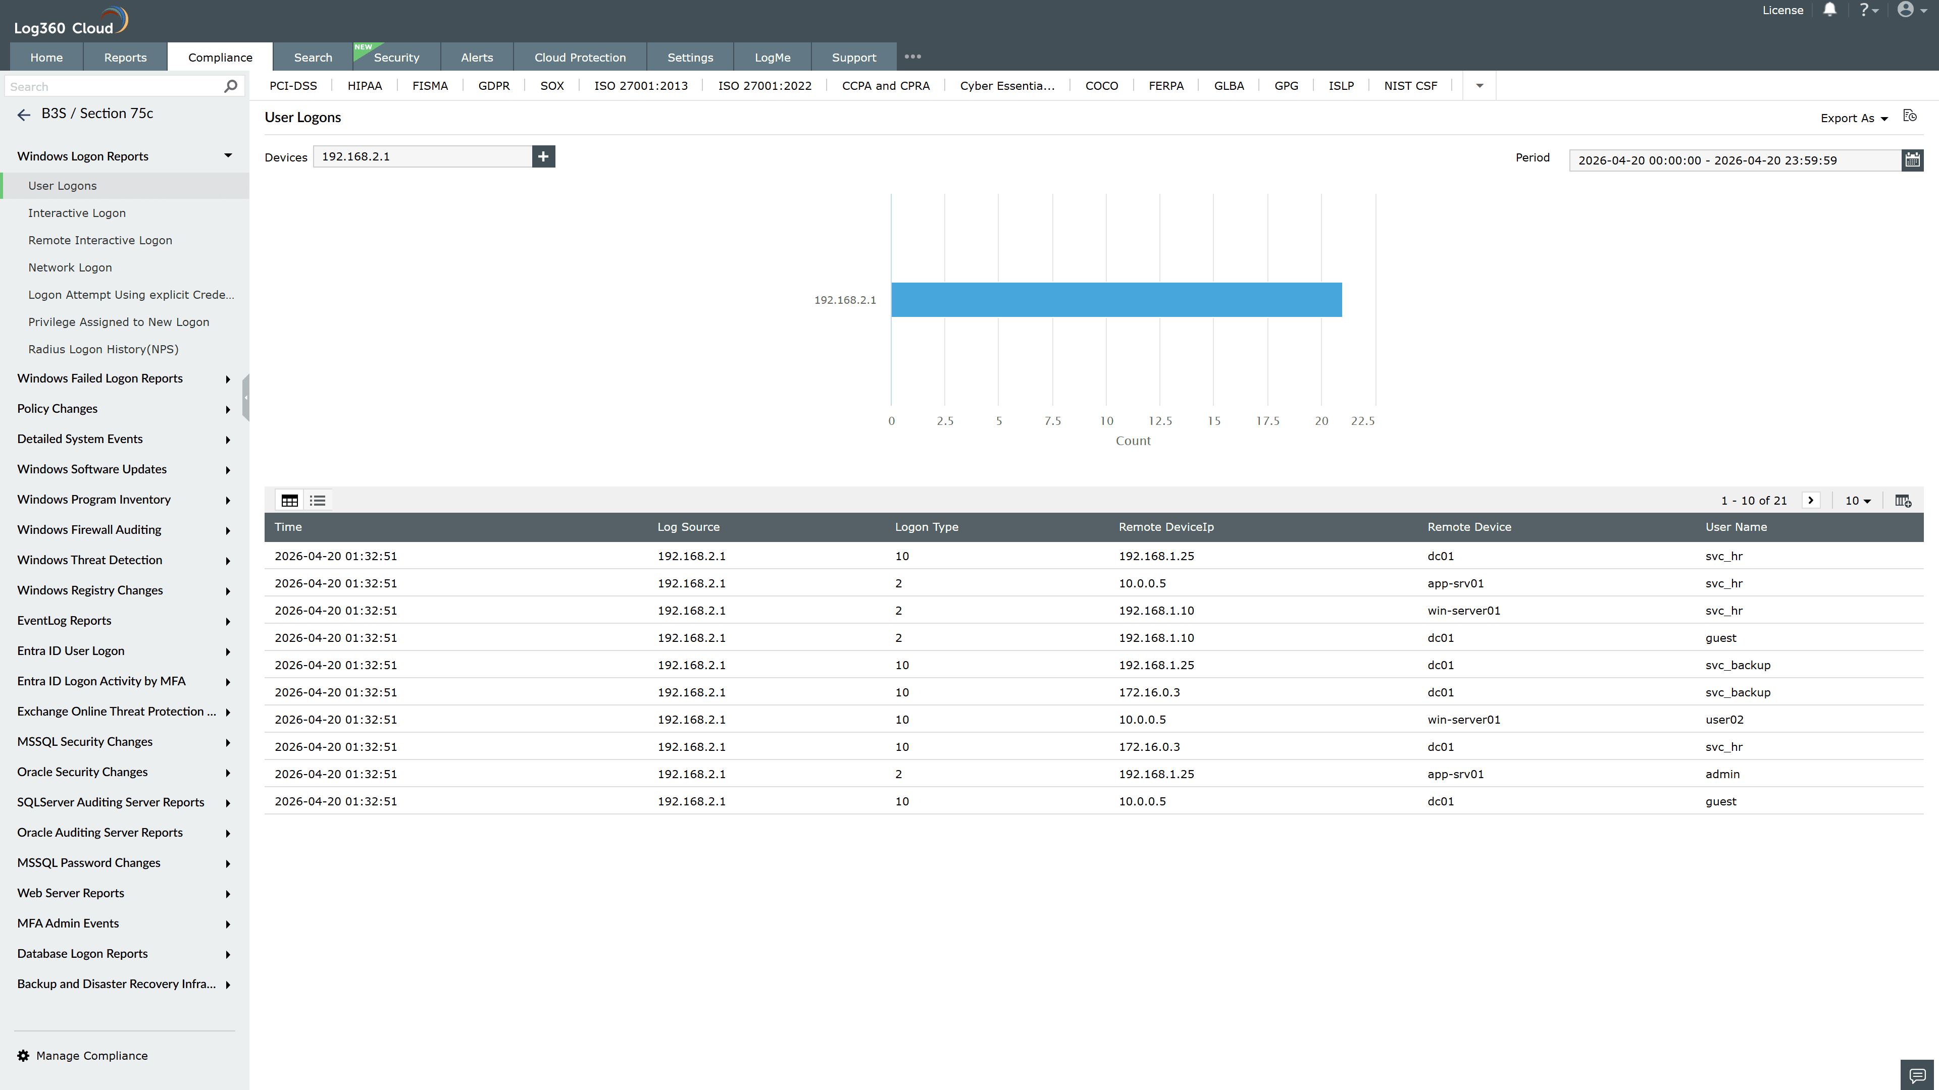
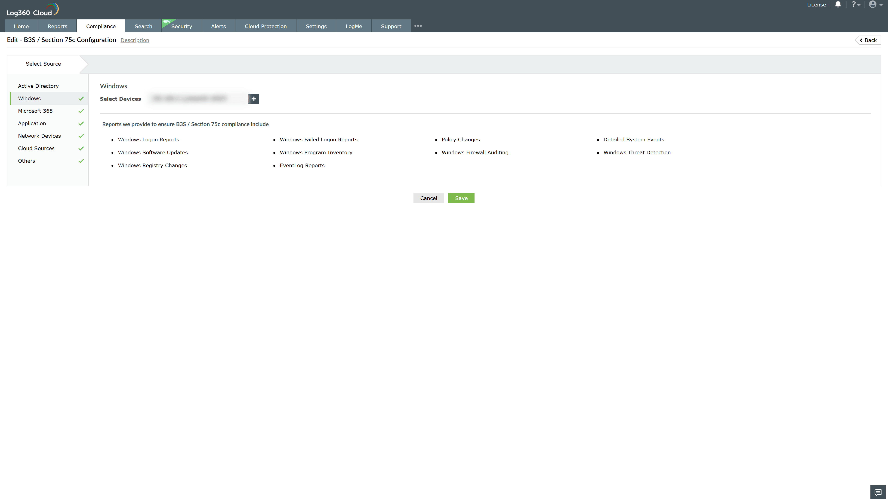

Valid Submission : Yes
Supported Editions : Free, Basic, Standard, Professional, MSSP
Help Document : https://www.manageengine.com/log-management/help/integrations/compliance-extensions.html
Help Video : Not provided
Tags : Log360, Compliance, Privacy monitoring, Data privacy, Regulatory compliance
Supported DCs : US, IN, JP, CA, AU, UK and EU
Privacy Policy:
Terms of Service:
Release Notes:
Predefined reports for the B3S Krankenhaus and SGB V Section 75c Compliance

